Case Study 1

Codelabs Report Link - *https://codelabs-preview.appspot.com/?file_id=10-iRDC36c95Iynmgjkk5vpyJPQQrI9bOUAQ40DXHGCM#13*

# Part 1-

· In this assignment, you are given a company to evaluate and understand how programmatic

services are integrated into applications.. As we discussed, there are multiple elements to be

considered when you evaluate various algorithmic marketing concepts. We looked at various

programmatic services incorporated into a company’s website.This part to help you understand

how different companies are leveraging marketing services. This isn’t one of the case studies

that will be graded but will count towards class participation

· The goal of this assignment is to evaluate a company (see below for allocations and

answer the following questions:

# What is the product?

· Sephora is a French Multinational Chain of personal care and cosmetics retail brand.

· Sephora offers beauty products such as cosmetics, skincare, body, fragrance, nail color, beauty tools, and haircare from approximately 3,000 brands, as well as its own private label.

· It follows Business-to-Customer Model (B2C) which refers to selling products directly between a business and consumers who are the end-users of the product

· There are various brands whose names start from A to Z, like

1- Givenchy- Which sells Gift sets, Makeup, Mini size products, fragrances, and men’s products

2- Versace- Which sells fragrances, mini size products, gift sets, men’s products, and body & bath products

3- Google- Which only has Google Nest Hub (which is categorized under Gifts, Tools & Brush)

# How are they selling it?

· Sephora follows the Business-to-Customer business model which allows customers to be busy directly from the website, also has the facility to place and pay order from stores, and also it has local stores for direct purchase of products.

· They are advertising products which are selling fast, and are new. Sephora products are also recommended and have a sign to indicate that a particular product is of Sephora.

· Sephora is selling products by giving various promotions like free gifts on a particular cart size and free delivery.

· Sephora is selling products by various categories like brands, skincare, hair fragrance, tools & brushes, bath & body, mini size products, gift sets, products under $20, Sales & Offers

# How is it priced?

· Pricing strategy defines the cost of products- generally termed as COGS

· Since Sephora has its own brand of products which are manufactured, they also consider cost-plus pricing model where production cost is added to profit percentage they determine

· Free or premium based pricing is applied by the company as it wants the customer to try a sample for lower cost hoping that they will upgrade or subscribe for a monthly payment to use the product

· Price is in format $xx.00

· There is also a range of prices given depending on the size of the product, big size is worth buying than the smaller size

· Original price is cut and discounted price is shown

# What promotions are they using?

· The basic purpose of promotion and advertisement services is to match customers with offerings and convey the right message to them.

· This is usually done by gathering data i.e. collection of input data (example- Customers personal and behavioral profile, inventory record and sales record)

· There are various promotions like-

1- Giving free gifts on birthday (While creating a new account, birthdate is to be entered)

2- Asking users to apply for membership so that they get free shipping and 2x points

3- Gives $10 off on completing 500 points

4- Giving some products free for cart value of $35

5- Giving free shipping by using promo code

6- Allows the user to select two sample products per order

7- Has a credit card program that gives 15% off when you pay using Sephora credit card

8- Gives products as rewards when 100 points are completed

# What algorithmic marketing services are they using?

· The marketing mix model defines four factors which are product, promotion, price, and place that company controls to influence consumer purchase decisions

· Marketing mix model can be broken down into functional services depending on the industry and business model of a particular company.

· Sephora follows the business-to-consumer (B2C) business model, here the mixed model is broken into defining six major functional services: promotions, advertisements, search, recommendations, pricing, and assortment.

· Promotion and Advertisements- There is a lot of promotion on the website, new, fast selling and popular products are advertised, products of their own brand are advertised on top of the page.

· Search and Recommendation- This service requires understanding the purchasing intent of the customer and match it with the right product which is in a similar price range and is advertised and promoted by a particular company. Sephora also has a feature of expert advice in which suggestions are given by experts on what product to buy if the user is confused.

· Pricing and Assortments- The price of the product recommended depends on the price of products that are already bought or are in the cart. The pricing and assortments model is used to price the products and arrange them in a particular way so that the user just continues to see the list of recommended products.

# What datasets do you think you will need to build these algorithmic services?

· Dataset will consist of customers’ personal (gender, age) and behavioral profiles (products which are added to cart/ wish list, the price range of products which user has purchased) and, inventory data (to show the products for recommendation and advertisement), and sales records ( sales record of user in order to predict new product)

a.How frequently will data change?

· This data will change every time when new products are added to cart/ wish list, and whenever a new purchase is made.

b.How would you store these datasets?

· Technology like machine learning and AI, I-SDS (Intelligent Software Designed Storage) systems which work like the human brain in order to develop intelligently, personalized storage systems can be used. This technology compiles all the data and sorts it, which allows speedy and efficient storage. This type of data can be stored on third-party cloud storage.

# Review the jobs/career site and search for Data/ Data science positions(<https://www.stitchfix.com/careers/jobs#below-the-fold>). After review of the site,what technologies and programmatic services is the company using?

· Prototype, test, and deploy algorithms that continue to improve upon the user experience

· Build new 0 to 1 algorithmic capability that delivers personalized content to clients

· Develop, lead and execute the strategic vision of client-facing search

· Build natural language processing systems

· Develop and use complex Bayesian and time-series models for prediction and inference

# How is the company tracking visitors?

· Sephora uses the Google Analytics 360 Suite to understand purchase trends when customers view a Sephora ad online or on mobile

· Sephora also uses TikTok Analytics

# Part 2-

· Your company is embarking on a project to build a marketing dashboard using

Snowflake & an analytics tool of your choice. They have asked you to build a prototype

and discuss the use case.

· Design:

# Start with the TPC-DS Dataset from Snowflake. Design a dashboard that will leverageQueries from Snowflake to build the dashboard.

**· Query 40**- Compute the impact of an item price change on the sales by computing the total

sales for items in a 30 day period before and after the price change. Group the items by location of

the warehouse where they were delivered from. Qualification Substitution Parameters

• SALES_DATE.01 = 2000-03-11

• YEAR.01 = 2000

*cs_sales_price - cr_refunded_cash as sales_before*

*cs_sales_price - cr_refunded_cash as sales_after*

**·** Used the result generated by the above query (Columns generated- i_item_id, w_state,

price_before, price_after) to build a dashboard along with the below query result to obtain clear

visualization.

· Fired query - *select * from item join catlog_sales on item.i_item_sk= catlog_sales.cs_item_sk;*

to get product name, category and other details of the items/ products whose i_item_id is

obtained as result in query 40.

· Dashboard-

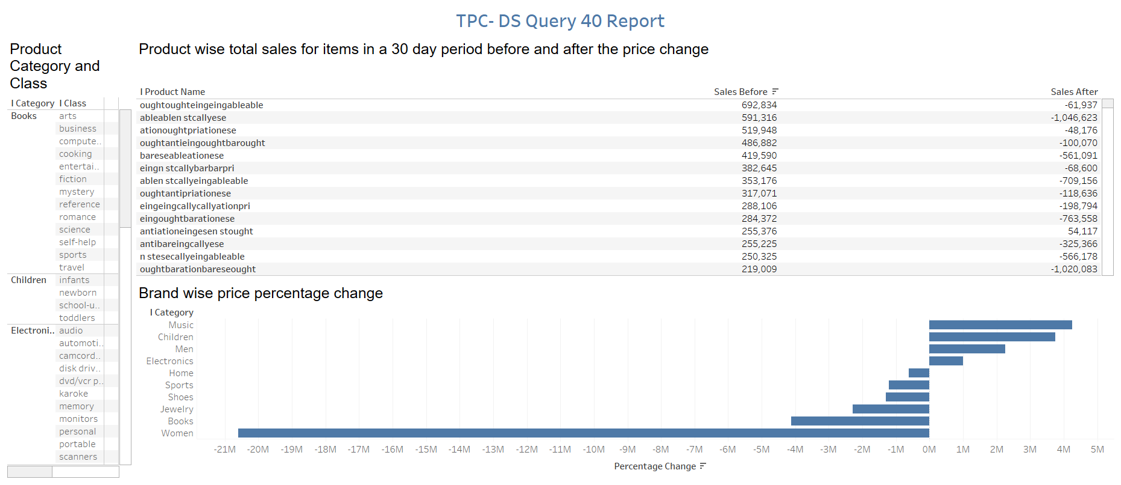

# 

# Discuss who is this dashboard targeted towards and the usecases you willaccomplish with it:

· The dashboard target the promotion & advertising, pricing, and sales department

to view the sum of sale of products according to category, class, and manufacture wise before

and after the price was changed.

· Also, the sum of percentage change shows which category has shown positive/

negative change after price change.

· **Usescases**- 1) Products that have negative sales can be traced and manufacturer can be

asked to lower the cost of the product.

2) Sales department can track the negative sale and target that particular category and advertise

it to people of that category of product and give promotions.

3) Pricing department can alter the price of products to make positive sales.

# 

# Your company wants to augment this dataset with a new dataset which will be in CSV format:

**i.Describe your design on how would you onboard the dataset**

**Preparing to Load Data:**

· Onboarding Dataset refers to the process of uploading the data from an offline into an online environment. For this, we will be uploading our CSV to the snowflake.

· We can start by clicking on “Create” and enter the name we want to assign to the database.

· Navigate to worksheet tab to create a table and define its schema using DDL script.

· Run the query.

· Table is created.

· Before we can load the data into Snowflake, we have to create a File Format that matches the data structure.

· From the Databases tab, click on the database hyperlink. Select File Formats and Create.

**Loading Data:**

· Use a data warehouse and the COPY command to initiate bulk loading of structured data into the Snowflake table we just created.

· Since we are using a trial version, we have COMPUTE_WH as our default warehouse which we will configure to meet our needs.

· Change the size depending on the size of the data. Multiple clusters are used for concurrency scenarios.

· Now we can run a COPY command to load the data into the table we created.

Eg: copy into trips from @citibike_trips

file_format=CSV;

· To clear the table: Eg: truncate table trips;

· Go back, Resiz the warehouse to Large and note the duration, bytes scanned, and rows.

**Create a New Warehouse for Data Analytics:**

· Navigate to the Warehouses tab, click Create..., and name the new warehouse ANALYTICS_WH with size Large.

· Go back to worksheets, change the warehouse to Analytics_WH and then run the query

Eg: select * from <table>;

**ii. Describe what tools (xsv, Python) will be used for data cleanup**

**XSV:**

· cat Concatenate by row or column

· count Count records

· frequency Show frequency tables

· join Join CSV files

· select Select columns from CSV

· slice Slice records from CSV

· sort Sort CSV data

· split Split CSV data into many files

· stats Compute basic statistics

· table Align CSV data into columns

**Python**:

· Missing Data: isnull()

Solution: Solution #1: Drop the Observation

Solution #2: Drop the Feature

Solution #3: Impute the Missing

Solution #4: Replace the Missing

· Outliers

Solution: scatter plot, IQR, and clustering

# Prototype your application

**i. Choose a marketing-related dataset from** www.kaggle.com, **criteo.com, etc.**

· Fast Food Marketing Campaign A\B Test (IBM Watson Analytics Marketing Campaign) -

A fast-food chain plans to add a new item to its menu. However, they are still undecided between three possible marketing campaigns for promoting the new product. In order to determine which promotion has the greatest effect on sales, the new item is introduced at locations in several randomly selected markets. A different promotion is used at each location, and the weekly sales of the new item are recorded for the first four weeks.

· Link- https://www.kaggle.com/chebotinaa/fast-food-marketing-campaign-ab-test

**iii. Pre-process it with xsv or Python.**

[*https://colab.research.google.com/drive/1940dmoxAeVCKtXK1f7KE7iDgD2OMmrP1?usp=sharing*](https://colab.research.google.com/drive/1940dmoxAeVCKtXK1f7KE7iDgD2OMmrP1?usp=sharing)

**iii. Show how will you upload it to Snowflake**

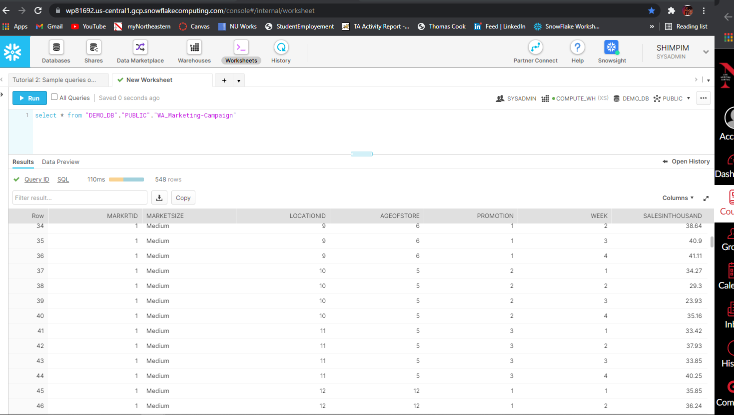

**iv. Show how this data can be visualized in an analytics tool of your choice.**

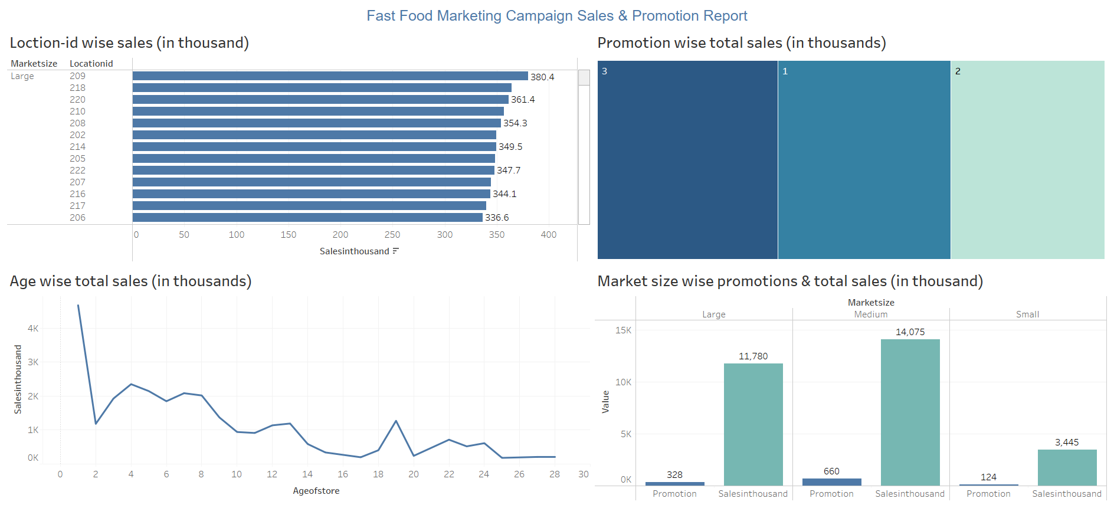

# GitHub Link-

[*https://github.com/MohitShimpi/Algorithmic-Digital-Marketing/tree/main/CaseStudy-%201*](https://github.com/MohitShimpi/Algorithmic-Digital-Marketing/tree/main/CaseStudy-%201)